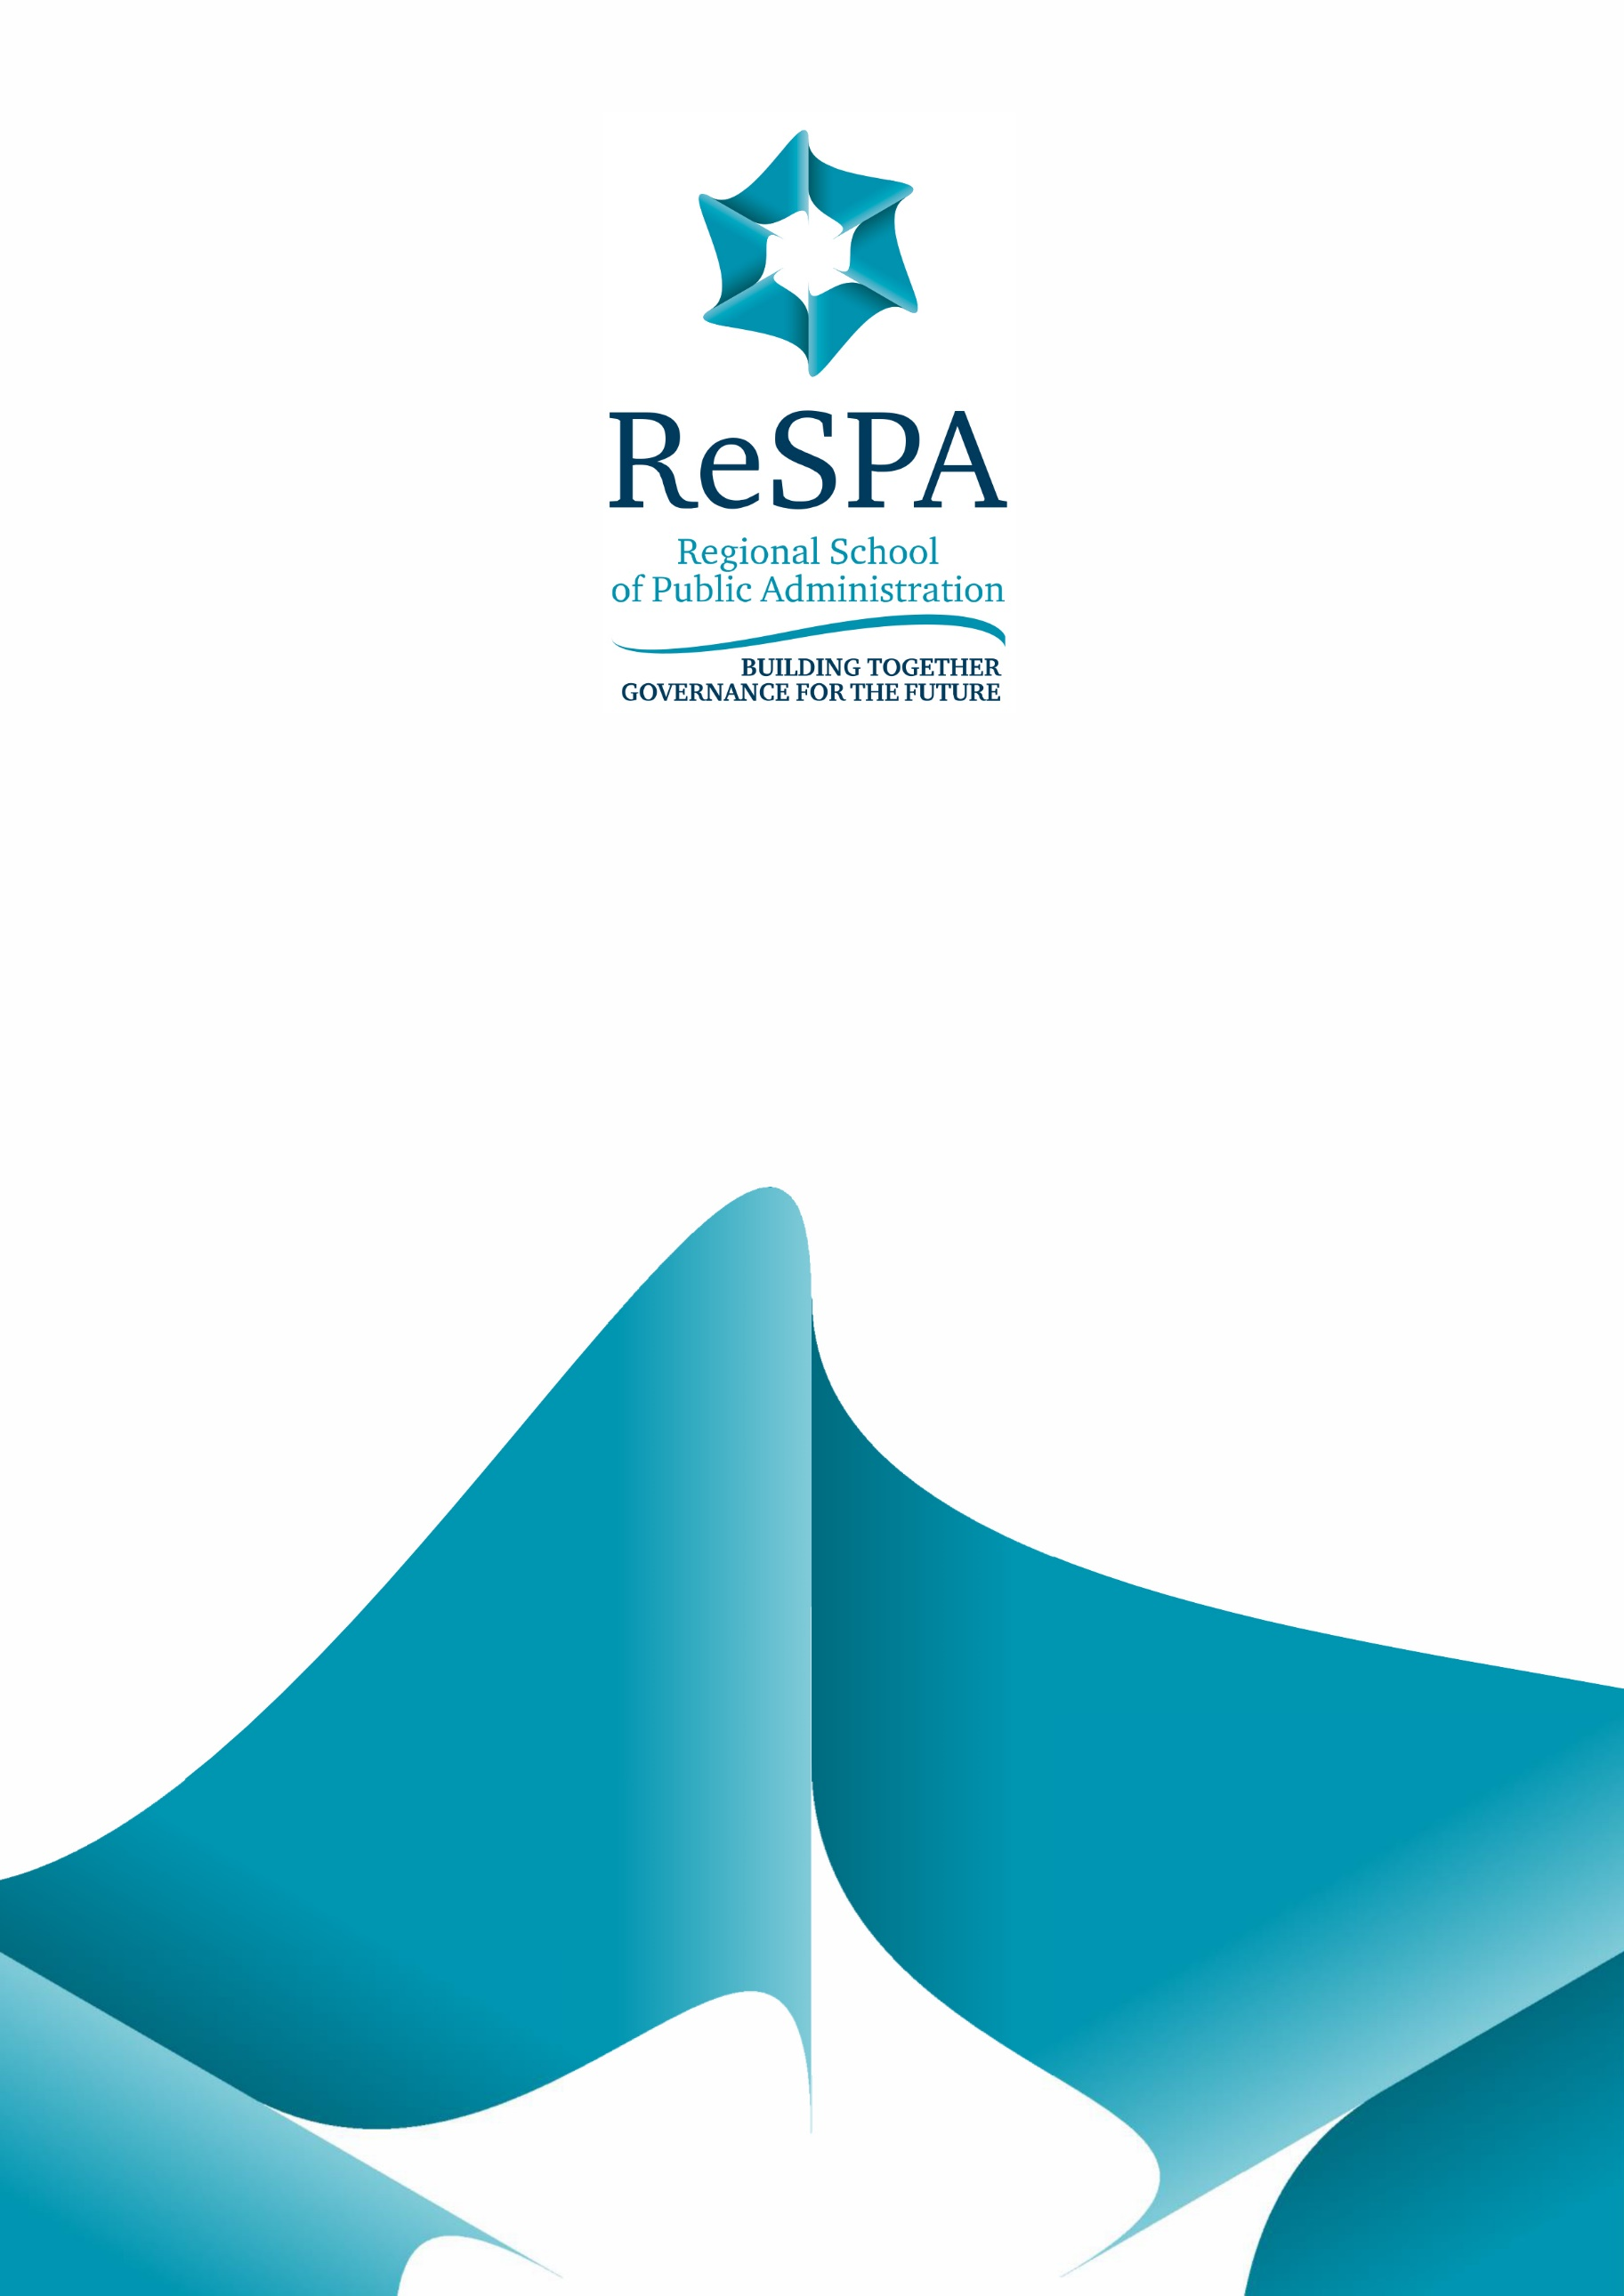



**Training for Regulatory Impact Assessment control authorities on all levels of government in Bosnia and Herzegovina**

19 – 21 September 2023, Agency for State Administration of the Republic of Srpska, Vladike Platona bb, Banja Luka, Bosnia and Herzegovina

**Background**

The Regulatory Impact Assessment control authorities on all levels of government in Bosnia and Herzegovina (RIA Training), as a capacity-building activity, is a kind of ReSPA‘s tailor-made support based on the on-demand support mechanism to one of ReSPA’s members – Bosnia and Herzegovina (BiH). More specifically, ReSPA intends to organize a three-day RIA Training for the participants from the RIA oversight and control authorities on the levels of Bosnia and Herzegovina institutions, the Republic of Srpska, and the Federation of Bosnia and Herzegovina. This is expected to improve the overall capacities of the RIA oversight and other control authorities on all government levels in BiH, also leading to the increased quality of legislation and policy documents, as well as background analysis and evidence, improving the policy-making process in general in the BiH.

RIA and inclusiveness in the adoption and implementation of regulation has been introduced into the decision-making procedure at all administrative levels in BiH. However, the scope of performance varies. Also, there is a diversity between the administrative levels in BiH when it comes to the policy and regulatory framework introducing and regulating RIA, as well as processes and procedures to be implemented to conduct the RIA properly and prepare quality RIA reports. It has been noted that it is necessary to continue the improvement of legal and methodological solutions and ensure a more consistent implementation at all administrative levels, including strengthening human capacities for the implementation of all the prescribed procedures and processes related to RIA. In addition, the existing capabilities of RIA implementation in BiH are often insufficient to keep up with the constant improvements in this field in the EU countries. This is even more difficult, given a constant turnover of personnel in other regulation-processing institutions and the need for continuous training since RIA requires systematic professional training to bring changes and new quality in the development of public policies.

Over the previous period of assessing training needs of BiH RIA oversight and other control authorities, as well as the needs of the personnel in line ministries and institutions with regulatory power, it has been noted that there is a need to transfer knowledge and experience with the best practice examples by experts who hold practical expertise in this field and who participated in developing and implementing RIA systems in different countries.

It has also been identified that some aspects of RIA training have been developed, and certain civil servants have been trained in the reform process so far. Although the process has been significantly improved, there is a need for capacity building, especially in the part of RIA implementation in transposition of Acquis Communautaire, RIA implementation in subordinate regulation and local self-government, SME test, cost-benefit analysis, implementation of the SCM model, monitoring and evaluation and ex-post analysis. Accordingly, it would be helpful to learn of the experiences of other countries in terms of the regulations that regulate the RIA process and the functions of the control bodies (content and form of the act by which the control is carried out, the obligatory quality and scope of the RIA application, subsequent control, etc.).

To sum up, the representatives of the institutions in BiH at different levels of government which coordinate the RIA activities and represent the central control bodies for RIA need to refresh their knowledge in this area to be able to pass it on to other colleagues at their levels of government, as well as to perform better their RIA oversight related functions and mandates.

Completing the RIA Training for the representatives of the control authorities on the levels of BiH institutions, the Republic of Srpska, the Federation of BiH, and Brcko Distrikt will help align the regulatory reforms in those administrations with the EU Better Regulation agenda. The RIA Training will also help reduce the existing diversity in the administrative structures, procedures and processes for the adoption and implementation of legislation and policy documents in BiH, as well as the variability among administrations when it comes to the process of improvement of the policy and regulatory environment and tools used for this purpose. More specifically, this will be achieved through cooperation between the administrative levels whose representatives will be participating in the RIA Training, exchange of experiences, and use of best regional and EU practices when it comes to the implementation of the EC Better Regulation agenda that will be presented and discussed during the RIA Training.

The training methods will include:

* Presentations to participants (ex-cathedra lectures) of the Better Regulation and RIA standards, steps and methodology. The presentations will consist of showcasing practical examples and will be interactive, which means that a continuous discussion with the participants will be pursued;
* Group discussions with participants on the previously learned lessons, their experiences, etc;
* Practical exercises and small group work regarding different aspects of RIA. A possibility to apply RIA techniques on actual files that the representatives of the BiH administrations needs to develop – will be utilized whenever possible;
* Brainstorming on the topics mentioned above, quick polls, etc.

**Agenda**

**DAY I, 19 September 2023 (Tuesday)**

|  |  |
| --- | --- |
| *12:00 – 13:00* | * *Welcome coffee and lunch* |
| 13:00 – 13:30 | * Presentation of RIA Trainer and participants * Presentation of the RIA Training and its objectives * Discussion about the expectations of participants |
| 13:30 – 14:15 | * Relevance of RIA * Why do RIA for draft legislation – primary and secondary, why do PIA for policy documents? * Benefits of conducting RIA * Importance and benefits of preparing a proper RIA report |
| 14:45 – 15:45 | * RIA Methodology – RIA steps, standards, processes, procedures and tools |
| 15:45 – 16:30 | * RIA in the EU and OECD countries, and in the EC – Policy, regulatory, methodological and institutional frameworks |
| 16:30 – 17:00 | * Wrapping up and evaluation of the first day |

**DAY II, 20 September 2023 (Wednesday)**

|  |  |
| --- | --- |
| 09:00 – 09:15 | * Summary of the main learning outcomes of the first day and key takeaways |
| 09:15 – 10:00 | * Practical exercise - Group work – Sharing experiences in conducting RIA for EU-related legislative files and overseeing the quality of RIAs conducted for EU-related files and quality of the draft EU-related files |
| 10:00 – 11:00 | * RIA in the context of the EU integration process, challenges in conducting RIA for EU-related legislative files and overseeing the quality of the legislation and RIAs conducted for EU-related files |
| *11:00 – 11:15* | * *Coffee Break* |
| 11:15 – 12:00 | * Practical exercise - Group work – Sharing experiences in identifying different sorts of impacts, with a specific focus on potential impacts on the private sector (e.g. through administrative simplification – cutting the red-tape, implementation of the SME test, assessment of impacts on competition and market, etc.) |
| 12:00 – 13:00 | * Presentation of the importance of identifying different sorts of impacts, with specific focus on potential impacts on the private sector – Presentation of and discussion on the SME Test and examples |
| *13:00 – 14:00* | * *Lunch break* |
| 14:00 – 14:30 | * Practical exercise - Group work – Sharing experience in identifying, quantifying and monetizing benefits and costs of different policy and legislative initiatives |
| 14:30 – 16:00 | * Presentation of the importance of identifying, quantifying and monetizing benefits and costs of different policy and legislative initiatives – Presentation of and discussion on SCM and CBA and examples |
| 16:00 – 16:30 | * Wrapping up and evaluation of the second day |

**DAY III, 21 September 2023 (Thursday)**

|  |  |
| --- | --- |
| 09:00 – 09:15 | * Summary of the main learning outcomes of the second day and key takeaways |
| 09:15 – 10:00 | * Practical exercise - Group work – Sharing experiences in implementation and enforcement, monitoring and evaluation, and conducting Ex-Post Analysis, as well as in overseeing the mentioned processes |
| 10:00 – 11:00 | * Presentation of the importance of the implementation and enforcement, monitoring and evaluation, and conducting Ex-Post Analysis |
| *11:00 – 11:15* | * *Coffee break* |
| 11:15 – 12:30 | * Presentation of cases of Ex-Post Analysis |
| 12:30 – 13:00 | * Wrapping up and evaluation of the third day * Wrapping up the RIA Training * Evaluation of the RIA Training |
| *13:00 – 14:00* | * *Lunch and the end of the training* |

**Trainer**

The trainer during the RIA Training will be **Dragana Aleksić**, an expert with more than 16 years in the Better Regulation area. Miss Aleksić worked as a high-level civil servant in the public administration of the Republic of Serbia for more than 10 years on evidence-based policy-making methodology development and implementation, with a particular focus on introducing Better Regulation principles and tools and particularly - RIA and its full implementation in Serbia. After this period, Miss Aleksić started working as an expert in different Western Balkan countries (besides Serbia – in Albania, Montenegro), Middle-East countries (Lebanon, Jordan), Moldova, Greece, Iraq, also on the introduction and implementation of Better Regulation principles and tools.

Besides the mentioned, Dragana Aleksić has extensive experience organizing and delivering RIA capacity-building programs in English (from 2007 onwards, she trained over 1k civil servants on Better Regulation and RIA in the mentioned countries). She has enormous experience organising and delivering training, workshops, and conferences on Impact Assessment (Regulatory and Policy), Public Policies, Strategic Planning, Improvement of Legislative Process and Quality of Legislation, Administrative Burden Reduction, etc. Recently, she has been engaged by SIGMA to assess the needs of the BiH RIA oversight and other control authorities for training on RIA and PIA, so she is more than familiar with the needs of future RIA Training participants.

Dragana Aleksić also has extensive experience in monitoring and evaluation of policies and legislation, conducting Ex-Post Analysis, and applying different analytical techniques within the RIA framework.